# Intro to JavaScript Week 1 Coding Assignment

**Points possible:** 70

|  |  |  |
| --- | --- | --- |
| Category | Criteria | % of Grade |
| Functionality | Does the code work? | 25 |
| Organization | Is the code clean and organized? Proper use of white space, syntax, and consistency are utilized. Names and comments are concise and clear. | 25 |
| Creativity | Student solved the problems presented in the assignment using creativity and out of the box thinking. | 25 |
| Completeness | All requirements of the assignment are complete. | 25 |

**Instructions:** In VS Code, or an IDE of your choice, write the code that accomplishes the objectives listed below. Ensure that the code compiles and runs as directed. Take screenshots of the code and of the running program (make sure to get screenshots of all required functionality) and paste them in this document where instructed below. Create a new repository on GitHub for this week’s assignments and push this document, with your JavaScript project code, to the repository. Lastly, in the Learning Management System, click the “Add Submission” button and paste the URL to your GitHub repository.

**Coding Steps:**

1. Create a new directory for this project and open the directory in your editor.
2. Create two new files in your directory, index.js and index.html.
3. Type the following HTML in index.html.

<html>

<script src="index.js"></script>

</html>

1. Inside index.js, create **one** variable for each of the following real-life examples and assign them values:
   1. Item price
   2. Amount of money in wallet
   3. Number of friends
   4. Age in years (as a whole number)
   5. First name
   6. Last name
   7. Middle initial
2. Create the following variables by performing operations (addition, subtraction, concatenation, etc…) on the variables created in the previous step:
   1. New amount of money in wallet after buying the item
   2. Number of friends you’ve made each year based on your age variable and your number of friends variable
   3. Full name based on first name, middle initial, and last name
3. Use console.log() to print out the values of all the variables you’ve created. Provide some detail as to what the value being printed is. For example, if I had a variable called favorite state, I would do the following:

let favoriteState = “AZ”;

console.log(‘My favorite state is: ‘ + favoriteState);

**Screenshots of Code:**

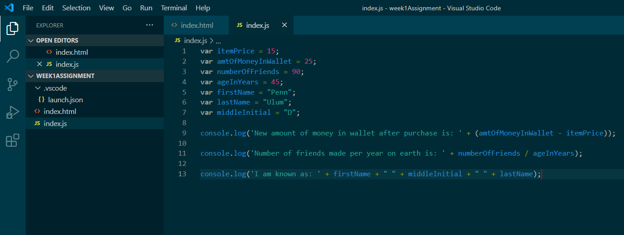

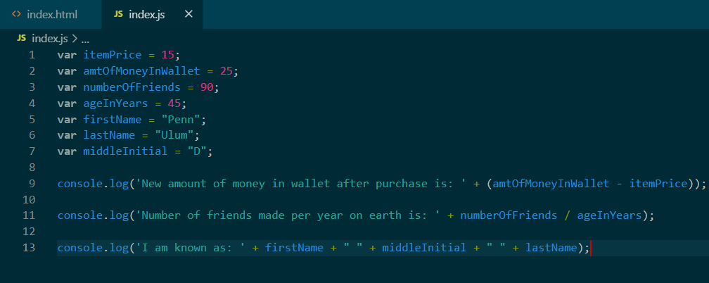

**Screenshots of Running Application:**

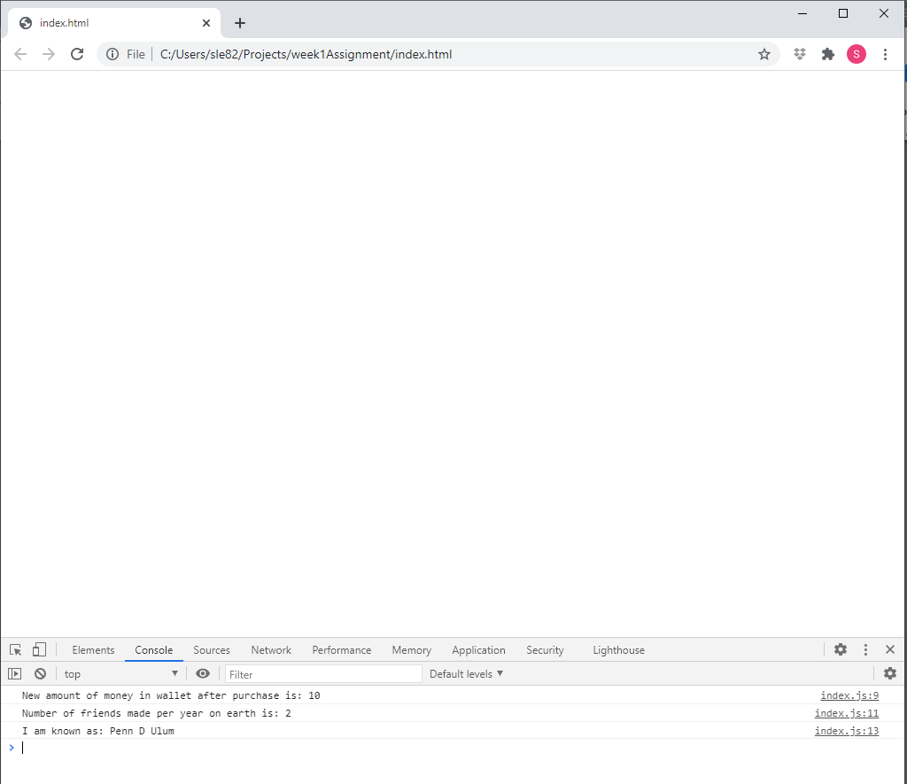

**URL to GitHub Repository:** [**https://github.com/meraki11/week1assignment.git**](https://github.com/meraki11/week1assignment.git)